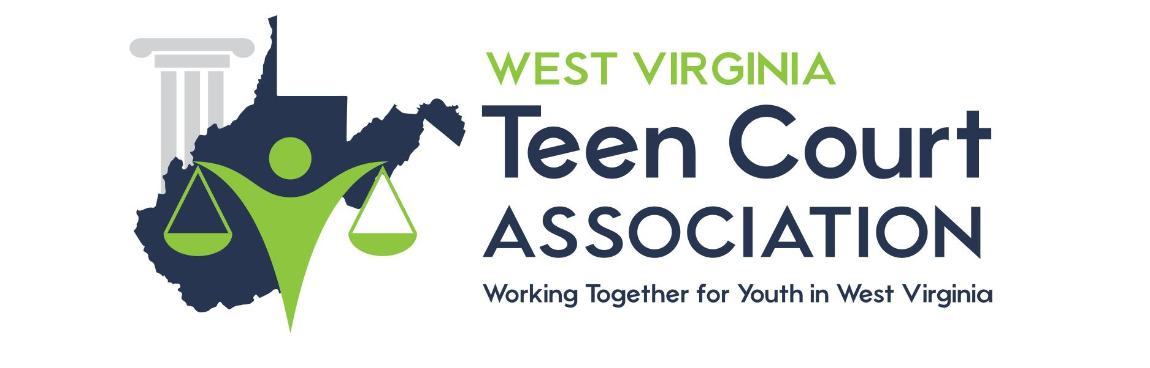

Dear Teen Court Defendant and Parent/Guardian,

Please take the time to complete the enclosed surveys and return them in the enclosed envelope. It is our intent to continually evaluate and improve the Teen Court Program.

Youth courts throughout the United States are gaining more and more interest. We want to make our program meet the needs of both the Justice System and the juveniles and families we serve. Only you who have been directly involved can help to make the program better. Your comments and responses to the enclosed surveys are critical in helping to make WV Teen Court Association meaningful. We want your honest answers and comments.

It is important that you respond and return the surveys to us. The evaluation company will process them for their annual report on WV Teen Court.

Sincerely,

Teen Court
Coordinator

