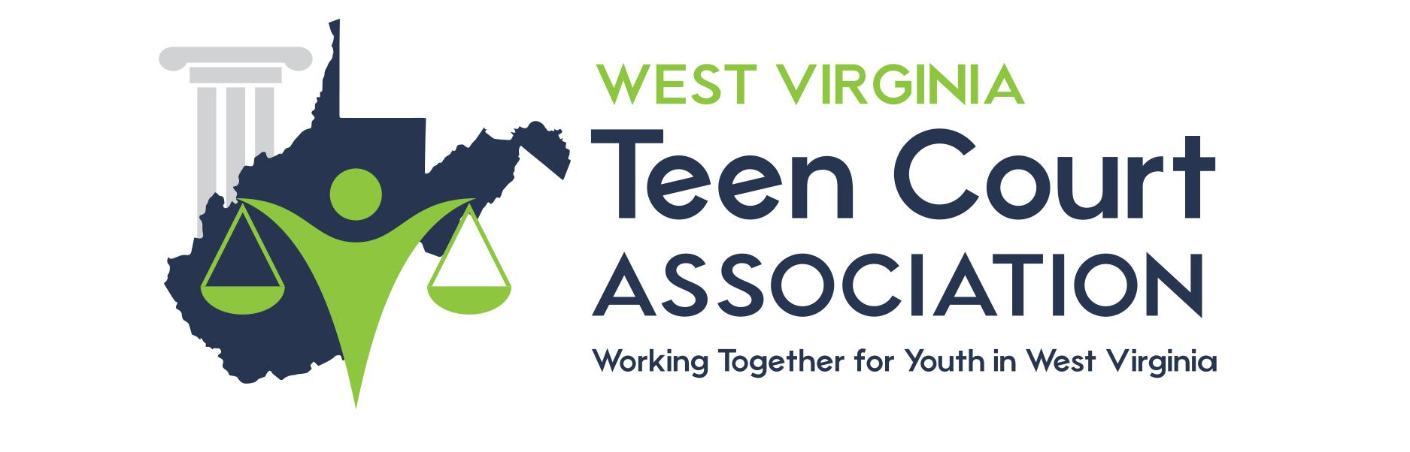

SUGGESTED TOBACCO PANEL QUESTIONS

- How long have you been smoking?
- How did you start smoking?
- Why did you start smoking?
- How do you get your cigarettes? How do you pay for them?
- Have you tried to quit smoking? Do you want to quit?
- Are you aware of programs and products to help you quit?
- Do you know the effects of using tobacco products?
- When do you smoke? (First thing in the morning, with coffee, etc)
- Has nicotine affected your life? Does it ever interfere or control your life?
- Do your parents know you smoke? Have they ever talked to you about smoking? How do they feel about you smoking?
- Do your parents smoke?
- Do your parents give you cigarettes or other tobacco products?
- Are you aware of the effects of second-hand smoke?
- Do you know it’s against the law for you to smoke? Do you know the consequences?
- How old were you when you smoked your first full cigarette?
- Have you ever given or sold tobacco products to anyone under 18 years old?
- Do you enjoy smoking?
- How does smoking make you feel?
- When caught smoking by your parents, what happened? Were there any consequences?
- Do you steal cigarettes? From your parents or friends? From a store?
- Do you have any hobbies, play sports or have any other activities in your life?
- Is there anyone in your life that has had a tobacco related illness? Are they still alive? Did you watch that process? How does it make you feel?

