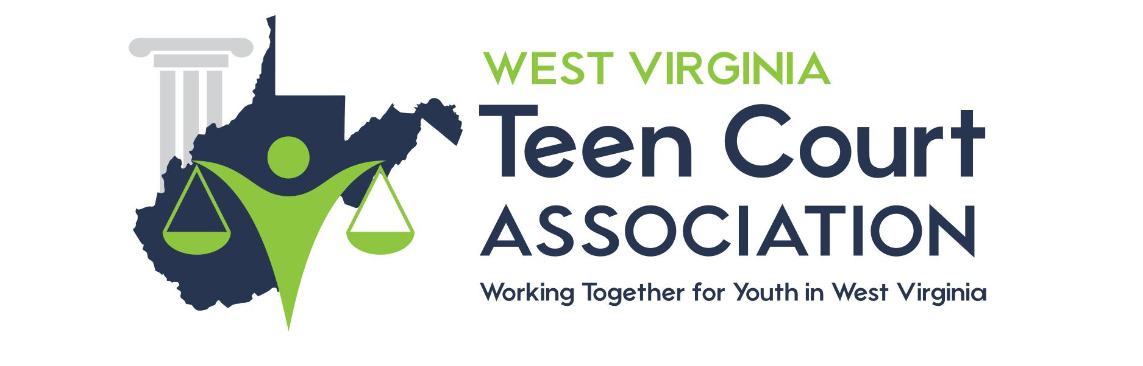

DRESS CODE LAWS

All public schools in West Virginia have adopted dress codes that prohibit any student from wearing any clothing or articles that promotes/advocates sex, drugs, violence, tobacco or alcohol, paraphernalia, gang-related writing or violence, logos, symbols, or activities. Refer to your school student handbooks for exact wording and details.

See your specific public school dress code.

