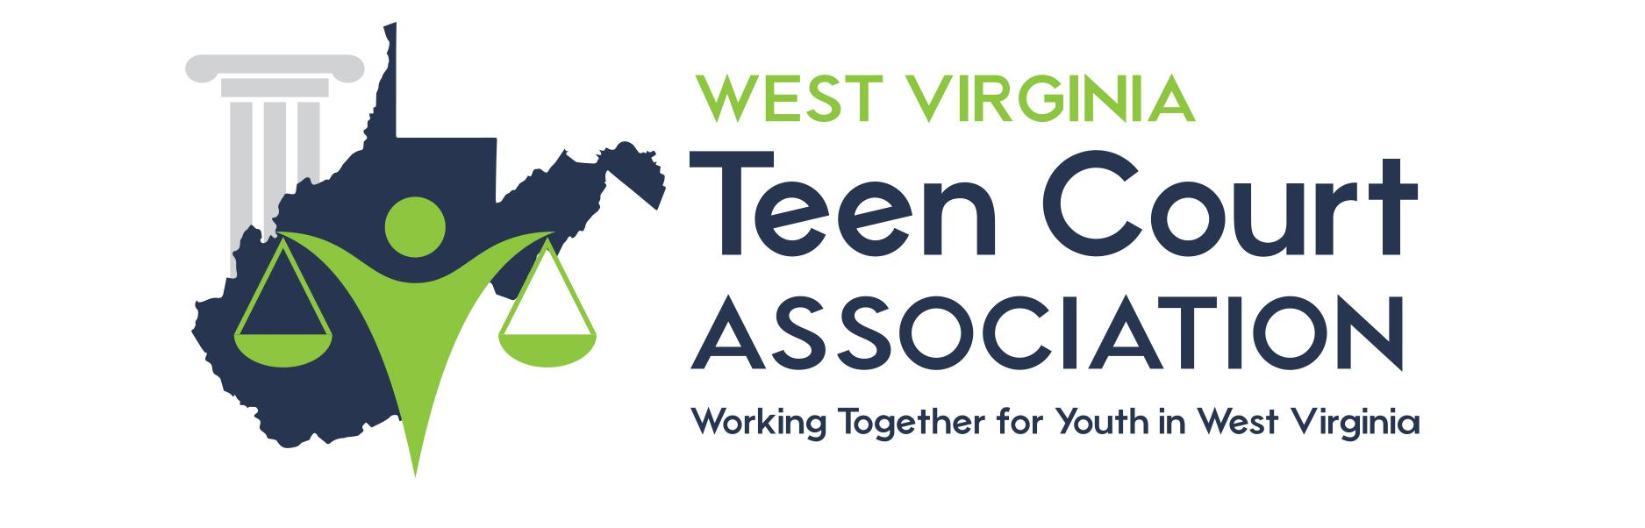

NO HELMET WARNING

I, _____________________________________, understand that I have been formally

warned for my violation of _____________________________________, code section

_____________________________________ on this date ________________, and

hereby acknowledge that any further citation for this violation will result in a full court

hearing.

_______________________________ ______________________________
Judge’s Signature

Defendant’s Signature

______________________ _____________________
Judge’s Name

Case Number

