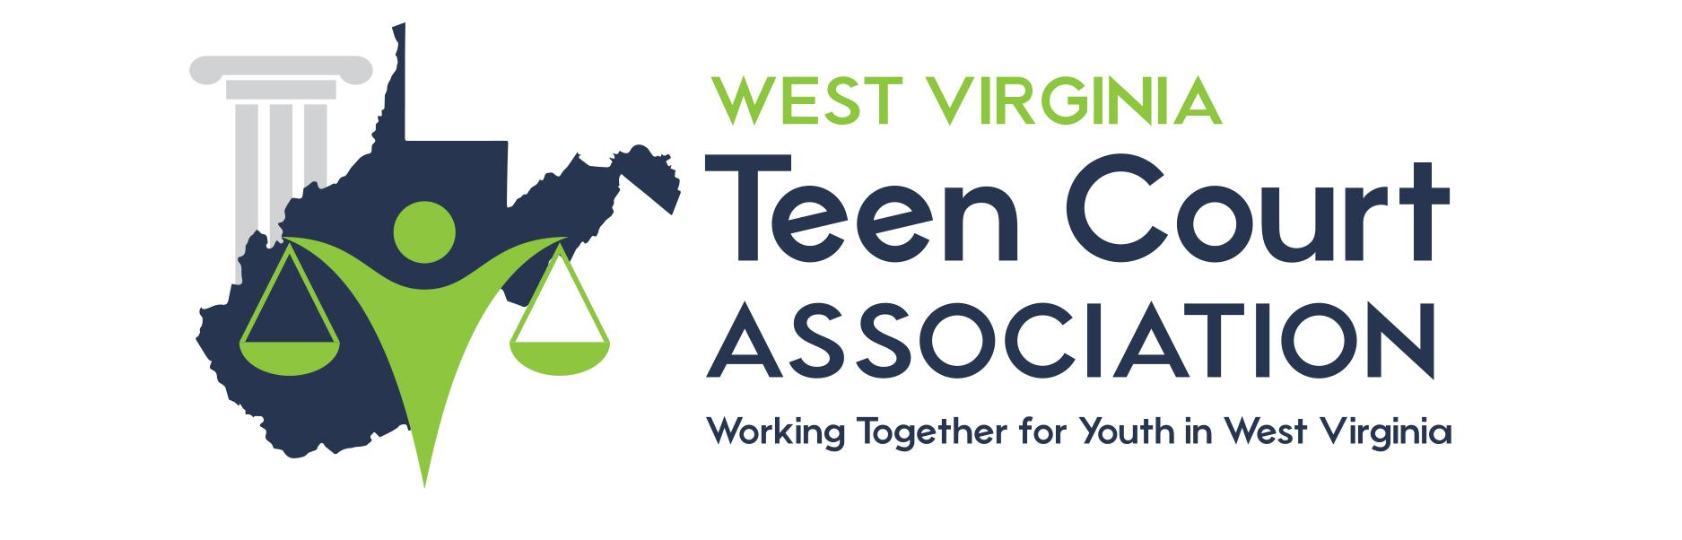

Date: ________________________________

Dear: ________________________________

After reviewing your WV Teen Court case, you still need to fulfill:

Jury Duties: _______________________________________________________

Community Service Hours: ___________________________________________

Essay: ____________________________________________________________

Letter: ____________________________________________________________

Classes: __________________________________________________________

Jail Tour: _________________________________________________________

Ride Along: _______________________________________________________

Counseling: _______________________________________________________

Other: ____________________________________________________________

____________________________________________________________

Failure to complete the components of your sentence indicates that your case will be returned to Juvenile Court.

Contact your case manager, _______________________________, IMMEDIATELY at:

Phone: (304) 913-4956 ext. (if any) _______

Email: ______________________________________________

