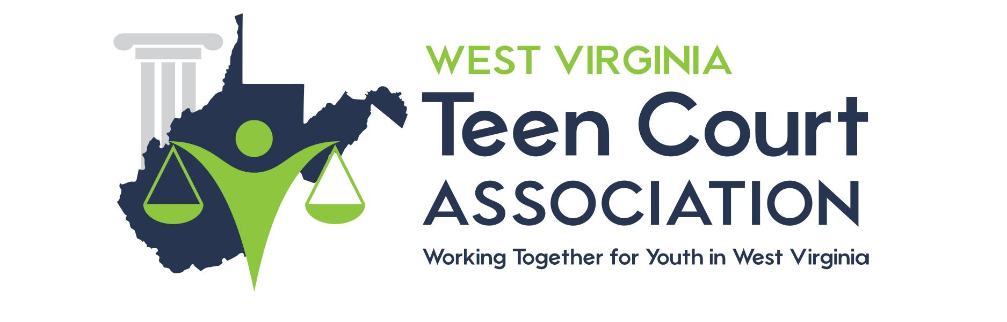

COMMUNITY IMPACT SURVEY

Thank you for your participation in the WV Teen Court Association. Please use the form below to provide us with your thoughts and reactions to the program. When finished, please place the form in the accompanying pre-addressed envelope and mail it to us.

1: Overall, how would you rate the usefulness of Teen Court?

Please Circle: Excellent Good Fair Poor

2: My role in Teen Court is:

Please Circle: Judge Mentor Attorney

Probation Officer Parent

Community Svc Coordinator Other: _______________

3: Why did you volunteer to participate in the program?

______________________________________________________________________________

______________________________________________________________________________

______________________________________________________________________________

4: Would you recommend other community members to volunteer with Teen Court?

Please Circle: YES NO

5: Do you feel Teen Court impacts the community in a positive way?

Please Circle: YES NO

6: What is the best part about Teen Court Court?

______________________________________________________________________________

______________________________________________________________________________

7: What part about Teen Court could be changed and why?

______________________________________________________________________________

______________________________________________________________________________

